Compact, High-Performance USB Flash Drive

[Watch Video](https://www.kingston.com/en/video/play?videoId=2kZX5IMtLnVyzaD4V77ozBrJkpmrzU6eiucGGyc7t9z9mS-GtU1SA1EanqAa0EWnnrdNJoGQKyrfrhiztoxKVw2&start=0&autoPlay=False&chromeless=False&captionOption=No)

DTKN

* [Intro](https://www.kingston.com/en/usb-flash-drives/datatraveler-kyson-high-performance-usb-flash-drive#product-features)
* [Specifications](https://www.kingston.com/en/usb-flash-drives/datatraveler-kyson-high-performance-usb-flash-drive#specifications)
* [Resources](https://www.kingston.com/en/usb-flash-drives/datatraveler-kyson-high-performance-usb-flash-drive#links)
* [Datasheet](https://www.kingston.com/datasheets/dtkn_us.pdf)

[**Buy**](https://www.kingston.com/en/usb-flash-drives/datatraveler-kyson-high-performance-usb-flash-drive#atc)

DataTraveler Kyson USB Flash Drivewith Stylish Capless Metal Case

Kingston’s DataTraveler® Kyson™ is a high-performance Type-A USB flash drive with extremely fast transfer speeds of up to 200MB/s Read and 60MB/s Write1, allowing quick and convenient file transfers. With up to 512GB2 of storage, you can store and share photos, videos, music and other content on the go. The capless metal design will save you the trouble of losing a cap, and the functional loop makes it easy to be taken wherever you go.  
  
DataTraveler® Kyson is a stylish, dependable USB-A Flash drive that comes with a limited 5-year warranty.

* Stylish metal and capless design
* Up to 200MB/s read speeds1
* Functional loop attaches to key rings
* Capacities up to 512GB2

Key Features

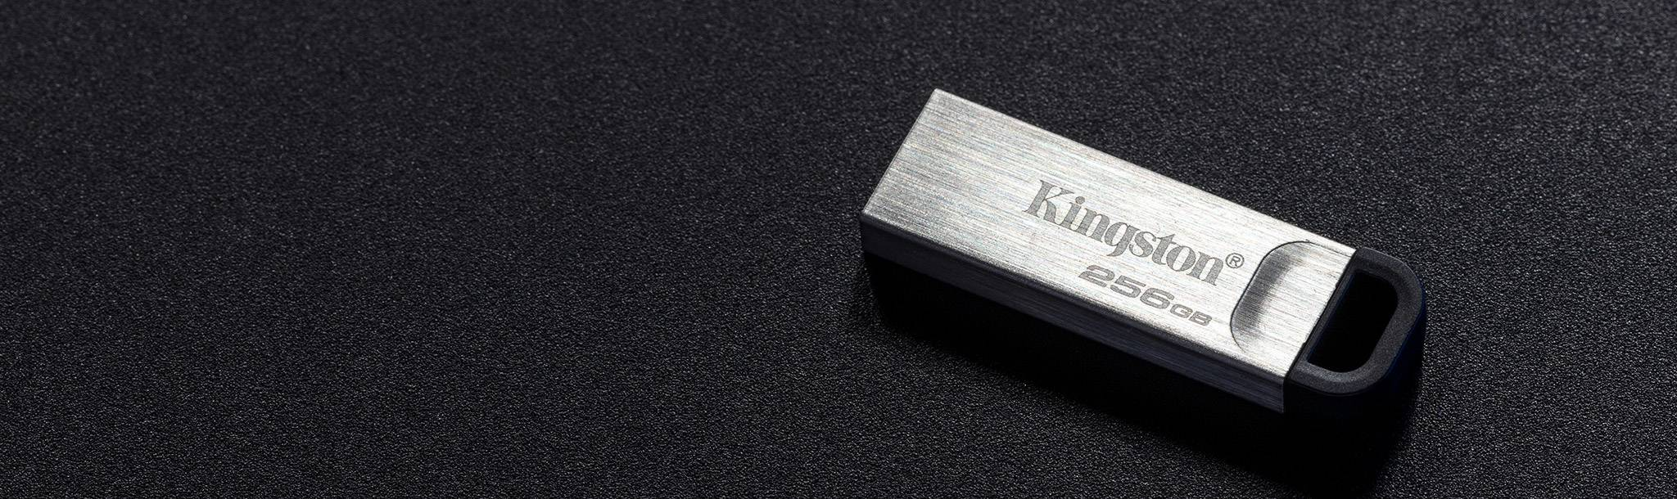

Durable and lightweight

The compact storage solution with stylish and durable metal casing



USB 3.2 Gen 1 speeds

Up to 200MB/s Read and 60MB/s Write1



Storage on the go

The capless design and the functional loop makes it easy to take with you



Large capacities

Up to 512GB2 for your files, photos, music, videos and more

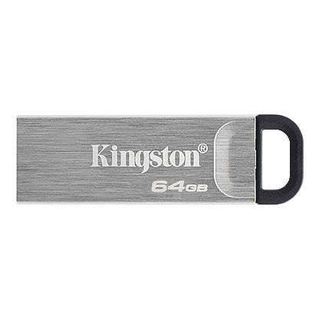

* [DataTraveler Kyson 64GB](javascript:void(0))
* [DataTraveler Kyson 64GB](javascript:void(0))
* [DataTraveler Kyson 64GB](javascript:void(0))

Capacity

 64GB

 128GB

 256GB

 512GB

* Part Number: DTKN/64GB
* Up to 200MB/s Read

[**Where to Buy**](https://www.kingston.com/en/wheretobuy)

Specifications

|  |  |
| --- | --- |
| Capacities2 | 64GB, 128GB, 256GB, 512GB |
| Speed1 | USB 3.2 Gen 1 speeds 64GB: 200MB/s read 128GB-512GB: 200MB/s read, 60MB/s write |
| Dimensions | 39mm x 12.6mm x 4.9mm |
| Weight | 4g |
| Operating temperature | 0°C~60°C |
| Storage temperature | -20°C~85°C |
| Warranty/support | 5-year warranty with free technical support |
| Compatible with | Windows® 11, 10, MacOS (v.10.15.x +), Linux (v. 4.4.x +), Chrome OS™ |